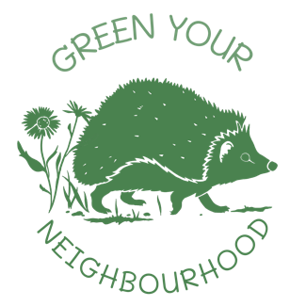

**Engaging Your Community with your Project**

*Thank you to Jasmine Walker from Nottinghamshire Wildlife Trust for providing the following information.*

Engaging your community is crucial for the success and longevity of your project. By involving people, you foster a sense of ownership, ensuring that community members will care for and maintain the project. Additionally, participation can enhance individuals' wellbeing by promoting outdoor activities and social connections. Here’s a comprehensive guide to effectively engage your community:

1. Clarify Your Message and Tone:

* Message: Clearly define what your project is, what you want from people, and how they will benefit.
* Tone: Determine how you will convey your message and communicate with the community.

2. Start with Your Network:

* Begin by talking to family, friends, and neighbours.
* Approach people in familiar places or consider door-knocking, which can be less daunting with a partner.

3. Utilise Social Media:

* Create events or regular meetups and form groups for project discussions. Social media campaigns can reach a wide audience but remember they may exclude those without internet access.

4. Leverage Traditional Methods:

* Use posters, leaflets, and business cards to advertise your project.
* Contact local radio stations or the press for coverage.
* Utilise community spaces like GP surgeries, libraries, and centres to put up posters or have stalls.

5. Engage with Community Leaders:

* Network with other groups doing similar projects and find community leaders who can champion your project.

6. Offer Diverse Involvement Opportunities:

* Volunteering: People can contribute through practical work like gardening or by offering skills in areas like communication, marketing, or fundraising.
* Skill Sharing: Encourage people to share their expertise and experience.

7. Create a Welcoming Atmosphere:

* Ensure people feel comfortable and included.
* Highlight the benefits of getting involved, such as learning new skills, meeting new people, and improving mental health.
* Value and incorporate community input to show appreciation for their ideas and involvement.

8. Plan and Celebrate Milestones:

* Have a clear plan with milestones to track progress and keep people motivated.
* Celebrate successes, no matter how small, to maintain enthusiasm and a sense of achievement.

9. Be Friendly and Approachable:

* Maintain a positive and welcoming attitude. Your enthusiasm will attract others to your project.
* Be patient and persistent, as building community engagement can take time.

By implementing these strategies, you can successfully engage your community, ensuring the sustainability and impact of your project.

**Learn more**

Learn more ways to Green Your Neighbourhood: <https://wildlifegardenproject.com/green-your-neighbourhood/>

To find out more about the topics in this document and much, much more, visit the Wildlife Trust’s Nextdoor Nature Hub: <https://nextdoornaturehub.org.uk/>

**About Green Your Neighbourhood**

With thanks to National Lottery players, we have launched an exciting new campaign, Green Your Neighbourhood!

Green Your Neighbourhood will allow us to help communities across the UK to create or enhance their local green space, and is being made possible thanks to a grant of £10,000 from [The National Lottery Heritage Fund](https://www.heritagefund.org.uk/).

The Wildlife Garden Project has worked alongside [Nottinghamshire Wildlife Trust](https://www.nottinghamshirewildlife.org/)to film community groups involved in[Nextdoor Nature Nottingham](https://www.nottinghamshirewildlife.org/nextdoor-nature), the Trust’s movement for nature, to launch a series of films and a national campaign. Our mission is to make it easy for people like you to take ownership of your local green space and take action that will benefit your local area, your community and wildlife.